TITTLE;

FOR LOOP IN PHYTON
OBJECTIVES;
USING (FOR LOOP) DISPLAY THE NUMBERS.
- FROM 0 TO 10.
- FROM 0 TO 100.
- EVEN NUMBERS FROM 0 TO 10.
- ODD NUMBERS FROM 0 TO 10.
- EVEN NUMBERS FROM 0 TO 100.
- ODD NUMBERS FROM 0 TO 100.
- TAKE INPUT FROM USER AND MAKE A TABLE.
TOOLS;
- PC.
- ANACONDA.
- JUPITER NOTE BOOK.
INTODUCTION;
FOR LOOP IS USED TO ITERATING OVER A SEQUENCE.THIS IS LESS LIKE THE FOR KEYWORD IN OTHER PROGRAMMING LANGUAGES,AND WORK MORE LIKE AN ITERATOR METHODE AS FOUND IN OTHER OBJECTS OREINTATED PROGRAMMING LANGUADES.
PROCEDURE;
- FIRST WE OPEN THE PC
- THEN OPEN THE JUPITER NOTE BOOK.
- AND WRITE A CODE FOR DISPLAYING THE NUMBER FROM O TO 10.
- AFTER THAT WRITE THE CODE FOR DISPLAYING NUMBERS FROM 0 TO 100
- THEN WRITE THE CODE FOR DISPLAYING EVEN NUMBERS.
- THEN WRITE THE CODE FOR DISPLAYING ODD NUMBERS.
- AND IN THE LAST WRITE THE CODE FOR TABLE WHICH TAKE INPUT FROM USER.
RESULT AND OBSERVATIONS;
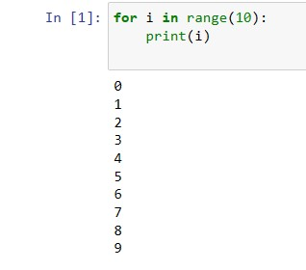  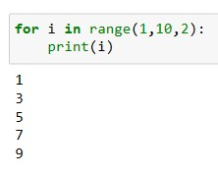 | 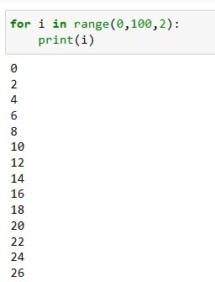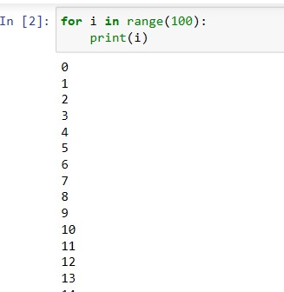
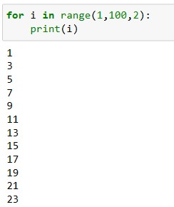 | 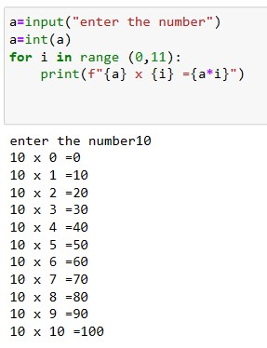
CONCLUSION;
HENCE WE ACHIEVED OUR LAB OBJECTIVES AND GET FAMILIAR WITH THE SOFT TOOLS.

